**Sudoku Solver Docker Playground Guide**

**Introduction:**

**Docker Hub:**

Docker Hub is a cloud-based registry service that allows you to store and share Docker images. It serves as a central repository for Docker images, making it easy for developers to distribute and access containerized applications. Docker Hub provides versioning, collaboration features, and integration with other services.

Welcome to the Sudoku Solver Docker Playground guide! In this guide, you'll learn how to use the Docker Playground to pull and run the Sudoku Solver Docker image, which provides a command-line interface.

**Step 1:** Access Docker Playground

Open your web browser and go to Docker Playground ([Play with Docker (play-with-docker.com)](https://labs.play-with-docker.com/)).

Click on "Start" to create a new Docker Playground session and then create a new session/instance.

**Step 2:** Pull the Sudoku Solver Docker Image

In the Docker Playground terminal, pull the Sudoku Solver Docker image from Docker Hub using the following command:

**docker pull venkatasaimohan/sudoku-solver**

This command fetches the Sudoku Solver image from Docker Hub and downloads it to your Docker Playground environment.

**Step 3:** Run the Sudoku Solver Container

Once the image is pulled, run a Docker container using the following command:

**docker run -it venkatasaimohan/sudoku-solver**

This command starts a container from the Sudoku Solver image and allocates a pseudo-TTY (terminal) for an interactive session.

**Step 4:** Solve Sudoku Puzzles

Explore the Sudoku Solver within the command-line interface. The Sudoku Solver will provide the output directly in the command prompt. Since the linux terminals are not GUI interface, we can’t get the pictures from docker container. We can assume the visualization plots will be like below:

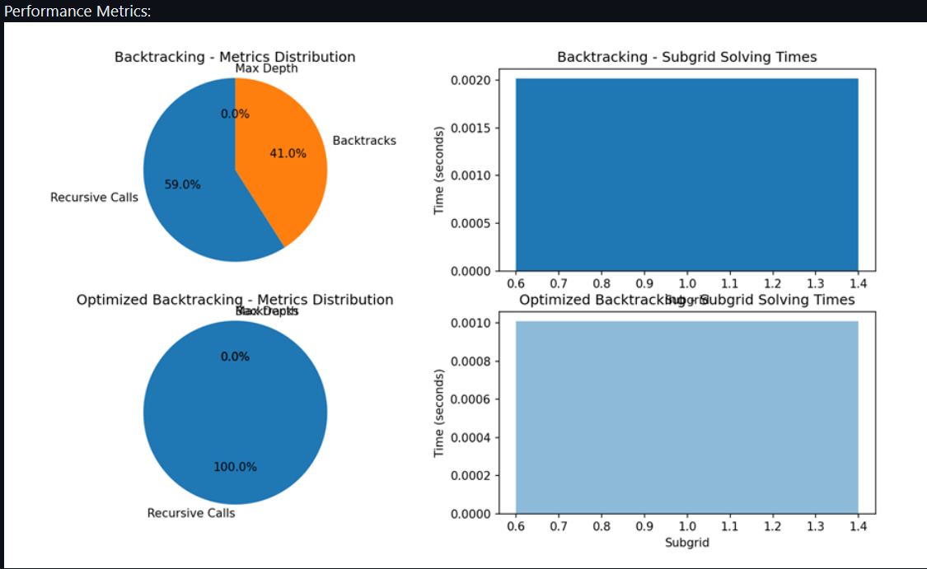

**Conclusion:**

Congratulations! You have successfully pulled and run the Sudoku Solver Docker image using the Docker Playground. Use the command-line interface to solve Sudoku puzzles directly in the terminal.

Note: The Docker Playground environment may have a time limit. If your session expires, you can start a new one by clicking on "Start" again.

Happy Sudoku solving!